# Resource sheet 5ii: Sample volunteer interview form

There are different approaches to taking on volunteers, with some being more formal than others. It is a good idea to have a plan for what you want to ask potential volunteers and a way to record their answers, whatever the level of recruitment process.

Below is a selection of commonly used questions that can be tailored to reflect the nature of the role, the individuals being interviewed and the needs of your organisation.

If you have more people interested in a particular role than you can accommodate, it is good practice to promote it with a deadline date. You can ensure fairness by interviewing the individuals who have registered their interest using a scoring system (e.g.,as below).

SCORING:

0 – Did not really answer question 1 – Partial answer 2 – Full answer

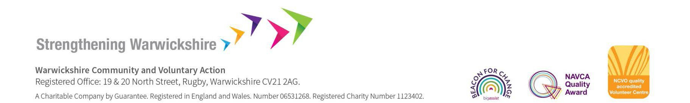

# Interview questions for *(insert role title*)

|  |  |
| --- | --- |
| Date: |  |
| Name of interviewee: |  |
| Name of interviewer: |  |

|  |  |
| --- | --- |
| QUESTIONS & RESPONSES | SCORING: |
| 1. What do you know about (organisation name)?  *How interested candidate is in the work that your organisation does?* |  |
| 2. Have you volunteered before? If yes, what did you do?  *Gain understanding of experience* |  |
| 3. Was there anything you particularly enjoyed about your previous volunteering or work experience?  *Understand what motivates the individual* |  |
| 4. Was there anything you didn’t enjoy about your previous volunteering or work experience?  *Understand what demotivates the individual* |  |

|  |  |
| --- | --- |
| 5. What is it about this role that interests you and which aspects appeal to you most?  *Understand individual’s motivation to do this role and which aspects motivate her/him the most* |  |
| 6. What do you hope to get out of volunteering in this role?  *Can organisation meet the individual’s expectations?* |  |
| 7. Are there any aspects of the role that do not appeal to you?  *Understand which aspects demotivate the individual* |  |
| 8. What skills and experience do you have that you could bring to this role?  *Does candidate have necessary experience and skill for the role?* |  |
| 9. Upholding equal opportunities is an important principal for *(organisation name)* and we believe that volunteering should be open to all. What is your opinion?  *What is the volunteer’s viewpoint of equality and diversity?* |  |

|  |  |
| --- | --- |
| 10. You have named (ref. name) as one of your referees. Bearing in mind we will be sending them a copy of the role description and person specification, what do you think this person would say about you?  *Is individual able to summarise own strengths and areas for development for this role, eg ability to operate as team member?* |  |
| 11. Do you have any questions you would like to ask us? |  |
| TOTAL SCORE (OUT OF A POSSIBLE SCORE OF 24) |  |

Items to note:

Earliest start date: ………………………………………………………………… Preferred hours to volunteer...…………………………………………………… Any special requirements ………………………………………………………… Any holidays already booked? …………………………………………………..

Other comments:

Signature of interviewer …………………………………………………………… Date…………………………………………………………………………………..

Warwickshire & Solihull Community and Voluntary Action

CAVA supports volunteer-involving organisations and groups across Warwickshire and Solihull in developing and maintaining good practice in their relationships with volunteers. We offer up-to-date information, advice and guidance on a range of topics including:

* Setting up a volunteer programme
* Developing volunteer roles
* Volunteer recruitment
* Volunteer retention
* Legal and insurance information
* Inclusive volunteering
* Addressing challenges with volunteers.

CAVA’s Resource Library

CAVA’s resource library contains a wide range of up-to-date, free resources for Warwickshire and Solihull’s community and voluntary organisations in the following topic areas:

* Groups & organisations
* Volunteering
* Safeguarding.

Visit [www.wcava.org.uk/resource-library](http://www.wcava.org.uk/resource-library) to view.

For more support and guidance

|  |  |
| --- | --- |
| For more support and guidance on any aspect of volunteer management, contact your local CAVA Volunteering Coordinator: | |
|  |  |
| North Warwickshire 🞟 Michelle Black  01827 718080 🞟 07458 017969  michelle.black@wcava.org.uk | Warwick District 🞟 Helen Wilkinson 01926 477512 🞟 07966 380276 helen.wilkinson@wcava.org.uk |
| Nuneaton & Bedworth 🞟 Tina Wragg  024 7638 5765 🞟 07966 380415  tina.wragg@wcava.org.uk | Stratford District 🞟 Fiona Anderson  07850 515197  fiona.anderson@wcava.org.uk |
| Rugby Borough 🞟 Carol Kavanagh 01788 539578 🞟 07966 380314  ckavanagh@wcava.org.uk | Solihull Borough  0121 312 3717  solihullinfo@wcava.org.uk |

DISCLAIMER

Although every effort has been made to verify the accuracy of materials in CAVA's resource

library, users are advised to check independently on matters of specific interest.